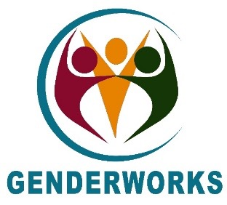 | 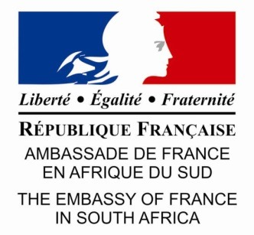 | 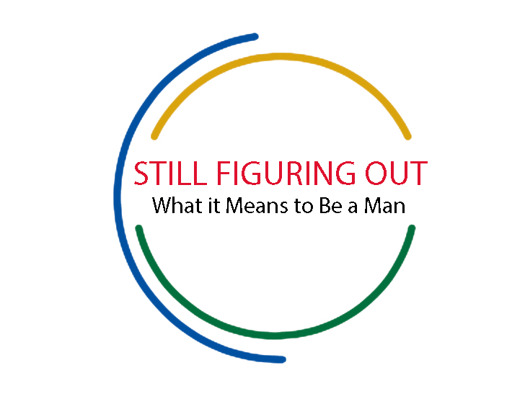

Gender Equity and Reconciliation workshop
Friday 7 - Sunday 9 December 2018
[9am - 5pm Friday I 9am - 6pm Saturday I 9am - 2pm Sunday]
Lycée Français 101 Hope St, Gardens, Cape Town.

The Embassy of France, Pretoria; GenderWorks, Cape Town; and the multimedia project “Still Figuring Out What it Means to be a Man”, invite you to a powerful and experiential workshop on transforming gender relations with women, men, and all gender identities. Using the unique approach of Gender Equity and Reconciliation, this 2.5 day workshop will bring together an unusual and diverse group of about 30 individuals of 18+ years including young professional men from the “Still Figuring Out” project; men and women from a range of NGOs doing exciting and transformational work across communities in the Western Cape; a wide range of community members; and members of the French Consulate and French network in Cape Town.

The Gender Equity and Reconciliation approach is groundbreaking and participatory: it creates a platform for the sharing of personal stories and gender journeys among participants to transform the very roots of patriarchy in a way that reaches far beyond an ordinary workshop. It provides a rare forum to jointly confront the personal, social, and cross-cultural origins of gender oppression and exploitation, and to reach mutual healing and understanding. Men are strongly encouraged and welcomed into Gender Equity and Reconciliation work, which involves no “male-bashing”, but instead inspires men to take part joyfully in the transformation of patriarchy in society, for the benefit of all humans. All sexual orientations and identities are welcome. You will be invited to share stories and participate in other experiential activities in pairs, small groups, and the plenary group: all within a carefully-facilitated environment.

Gender Relations in South Africa
In every segment of society, irrespective of race, class, religion, or sexual orientation, women and men grapple daily with the profound impacts of cultural conditioning around gender and sexuality. It is the daily acts of violence and micro-aggressions which take place within many intimate relationships that establish the social conditions which bring about violence on a greater scale. South Africa’s 350-year history of slavery, imperialism, colonialism, and apartheid has entrenched social inequality, and specifically racial and gender inequalities. The prevalence of rape in the country stems in part from the history of oppression, which has produced social and gender relations of a militarised society, and has nurtured violent masculinities. This workshop recognises the intersecting realities of racial and gender oppression, and addresses and transforms the very roots of patriarchy in a way that promotes healing for all.

Impacts of Gender Equity and Reconciliation workshops
Gender Equity and Reconciliation workshops have significant impacts on participants’ lives, attitudes, and behaviours. Men often report a new awareness of the plight of women and other genders in patriarchal society, and a commitment to curb their own afflicted behaviours (or violence), and that of those around them. Women and other gender identities often report healing from gender-based violence and trauma, and a new understanding of the ways that men are negatively affected in our patriarchal society.

